PDPM – soft required

Here is the full screen (for context)

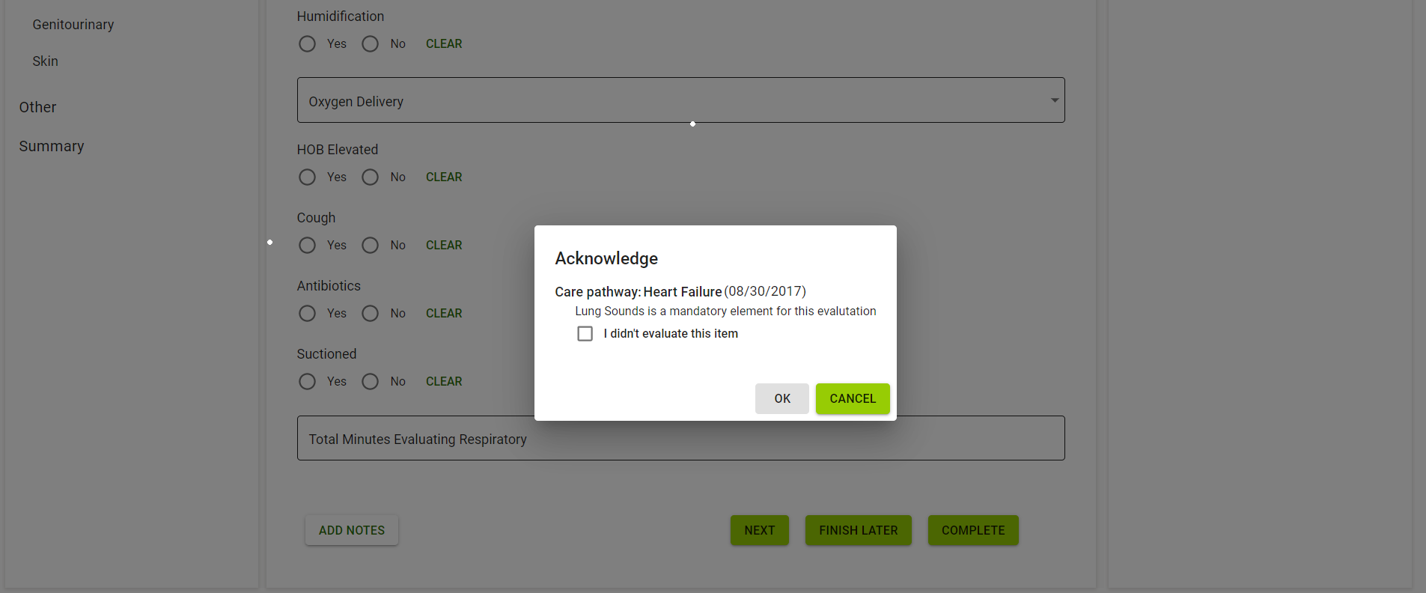

The screen will be more “tight” and focused. It should not be in view by default but, allow the user to scroll down if needed/wanted. Should show some of the assessment question content behind popup and the nav at the bottom of the screen.

